Copyright for test papers and marking guides remains with *West Australian Test Papers.*

Test papers may only be reproduced within the purchasing school according to the advertised Conditions of Sale.

Test papers should be withdrawn after use and stored securely in the school until Friday June 15th 2018.



**MATHEMATICS**

**SPECIALIST**

**UNIT 3**

**Semester One**

**2018**

**SOLUTIONS**

***Calculator−free Solutions***

1. Since are roots, then is a factor. ✓

dividing by gives the quadratic factor ✓

and using the quadratic formula gives ✓✓

✓ [5]

2. (a) ✓✓

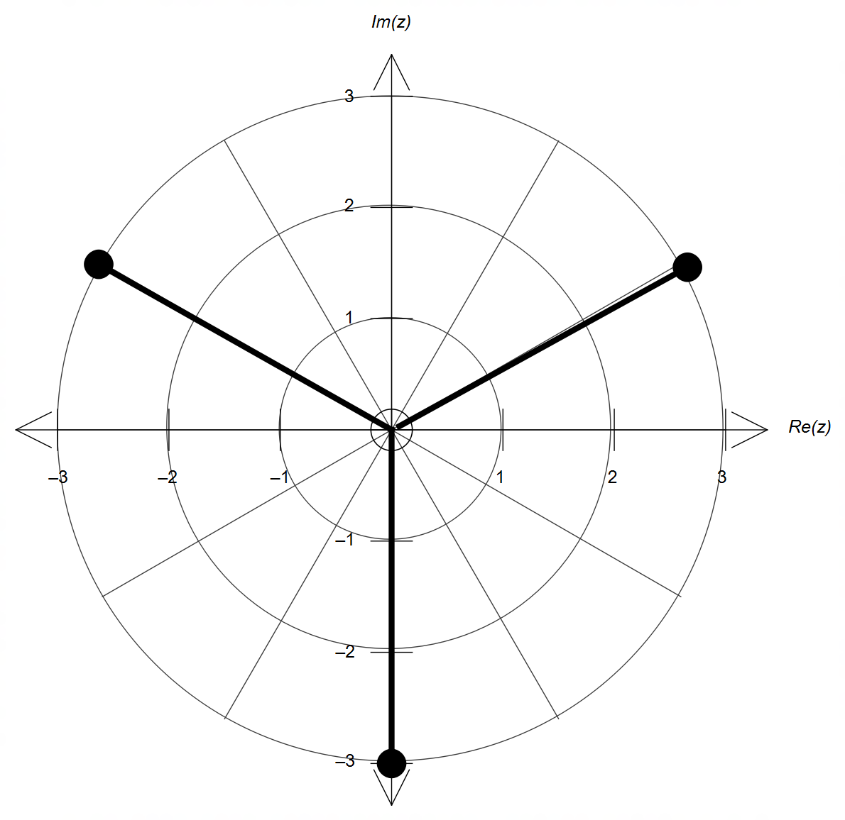 (b)

✓ magnitude = 3

✓ radians apart

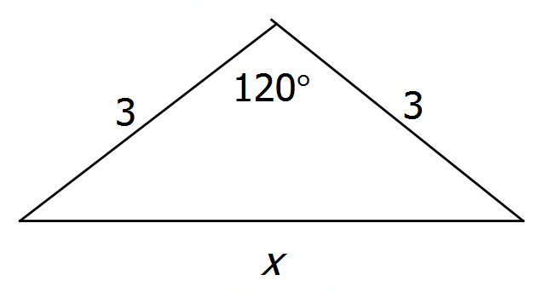 (c)

✓

✓

perimeter units, ✓ [7]

3. (a) ✓

✓

(b) ✓

✓✓✓ [6]

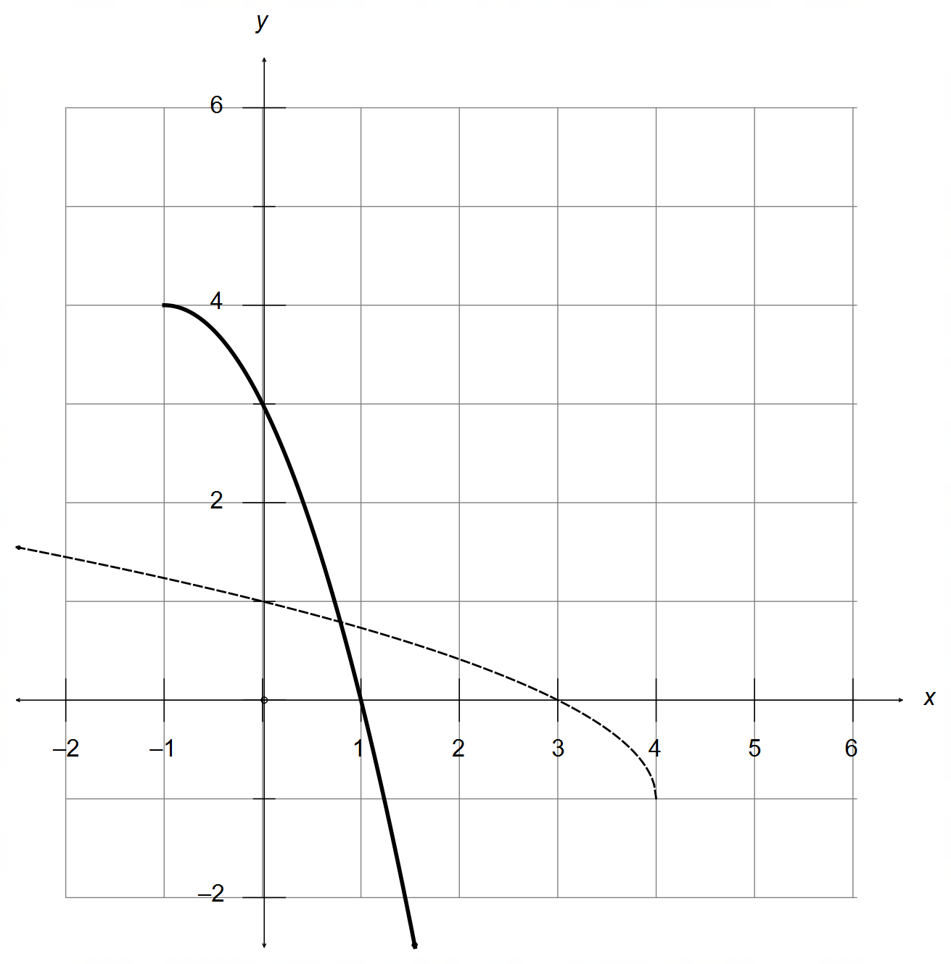4. (a)

✓ intersects f(x)

along the line y=x

✓ correct shape and location

(b) ✓✓

Domain ✓

(c) ✓

(d) Condition for composition to exist: ✓

✓

no changes needed for the domain of ✓

Range ✓ [10]

5. (a) ✓

OR ✓

(b) Use as the normal vector of the plane ✓

✓

✓

5. (c) ✓✓

✓

(d) Radius ✓

Centre ✓

✓

✓ [12]

6. (after long division or otherwise) ✓

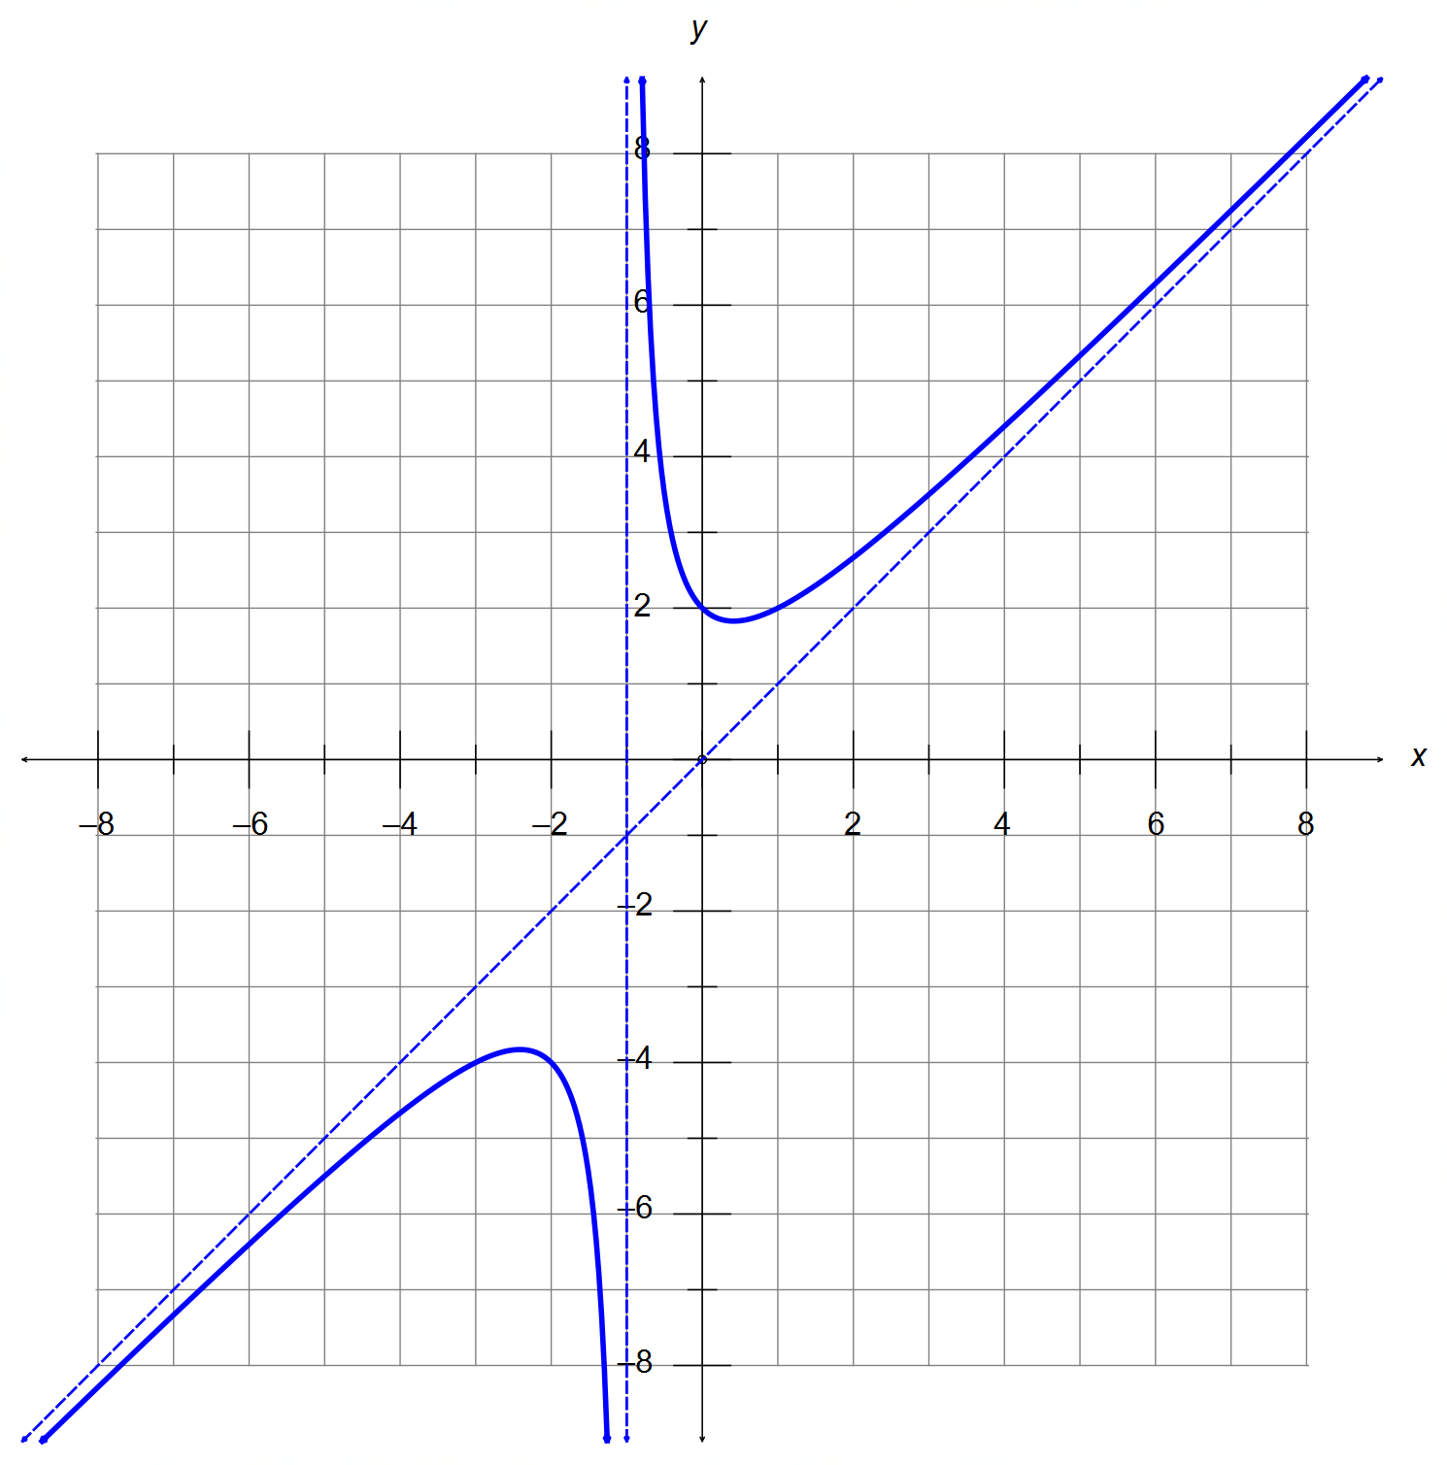

✓ Vertical asymptote x=-1

✓ Oblique asymptote y=x

✓ y intercept at (0,2)

✓ Shape and accuracy

[5]

7. (a) ✓

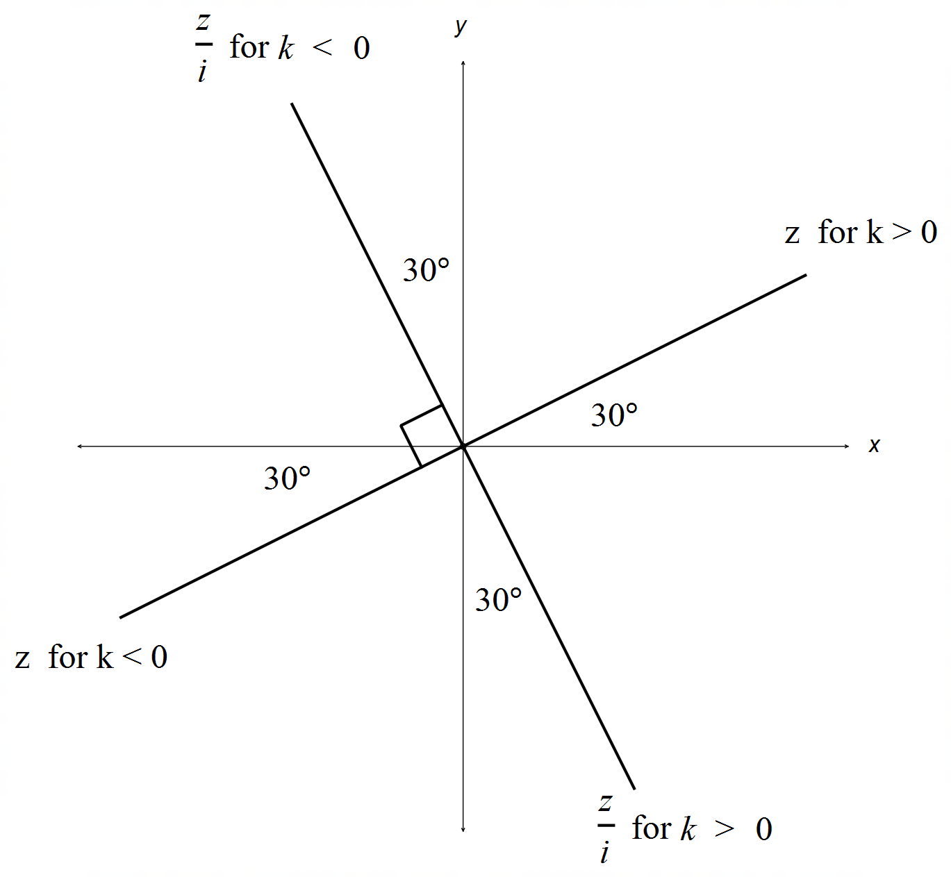 (b)

for ✓

for ✓

(c) for ✓

for ✓ [5]

***Calculator−Assumed Solutions***

8. For ABC to be collinear, AB // AC // BC (any two)

✓

✓

✓✓ [4]

9. (a) ✓✓

(b) ✓✓

(c) speed ✓✓

max speed at or

✓

✓✓

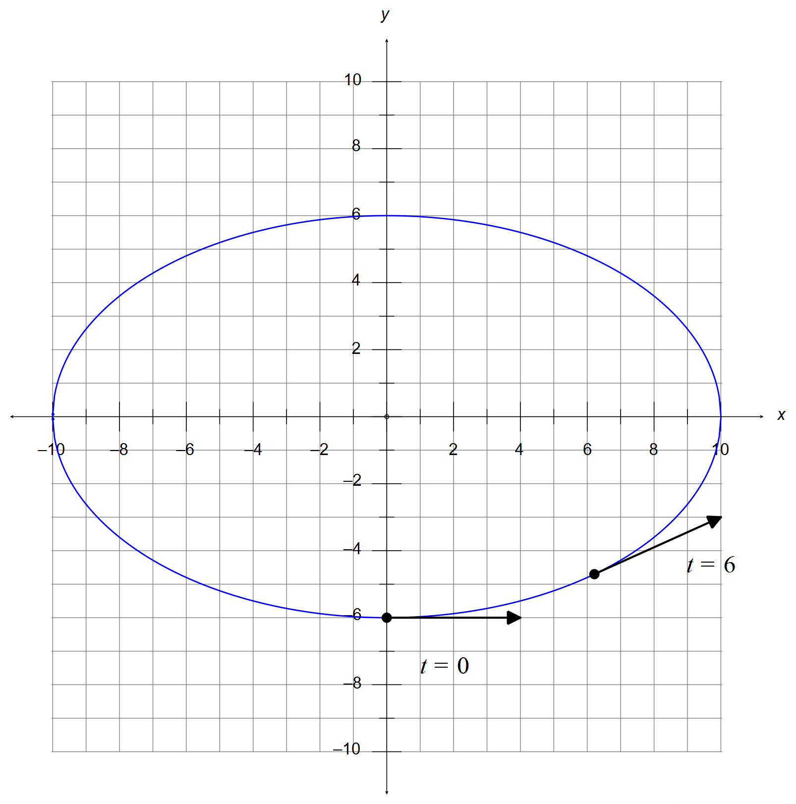 (d) Elliptical path with intercepts and ✓✓

✓

✓

✓

✓

[15]

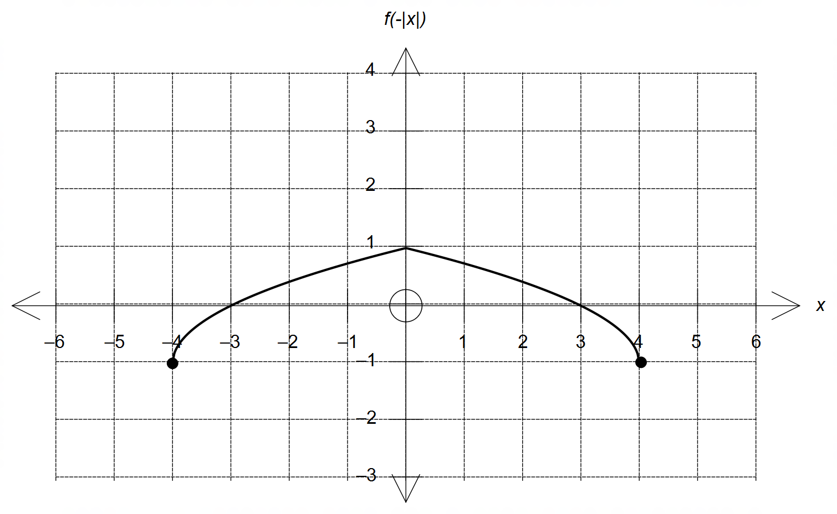10. (a)

✓ Mirror image curve

over the y axis

✓ Location and accuracy

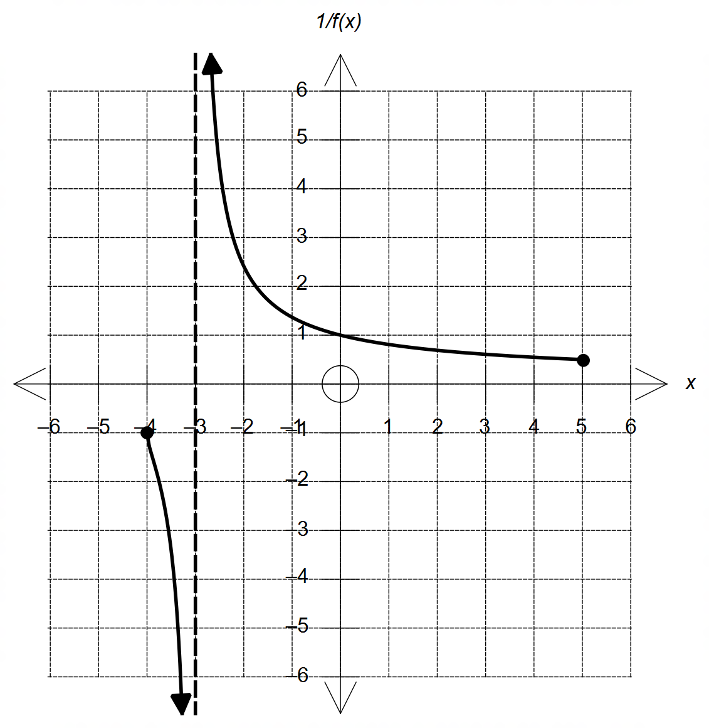 (b)

✓ Vertical asymptote

x = -3

✓ Indicates y →|∞|

as |x| → -3

✓ Correct domain.

✓ crosses f(x) when

y=1 or -1

(c) from the graph below ✓✓ [8]

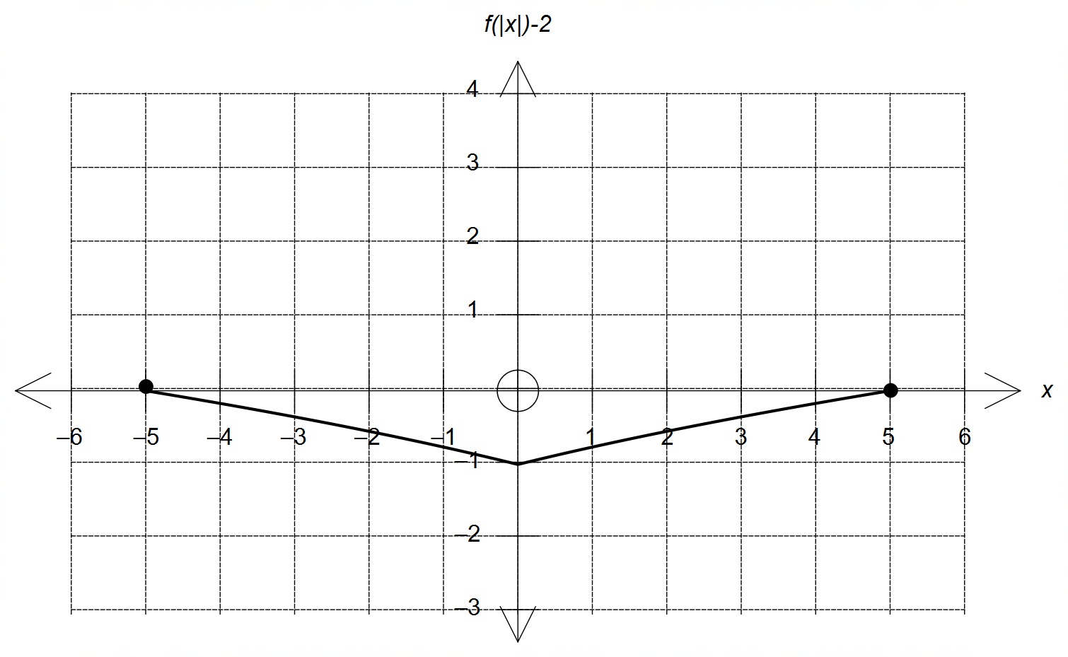

11. (a) (i) ✓

✓✓

(i) ✓

✓✓

(b) Let and

✓

✓

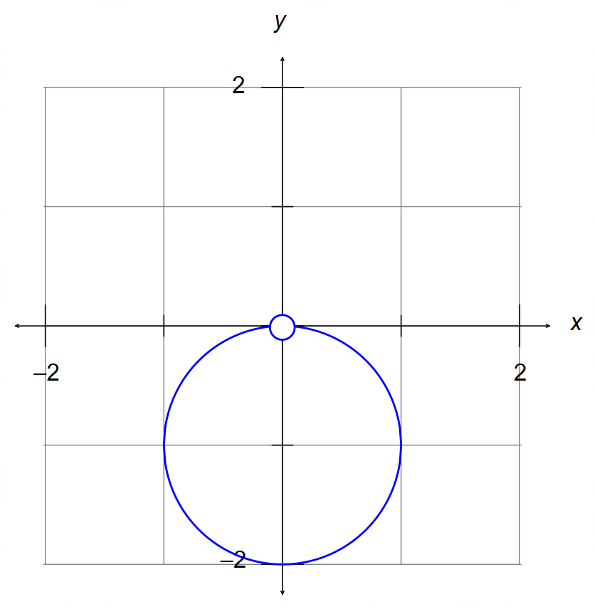

✓ circle centred at

(0,-1) with radius = 1

✓ discontinuity at the origin

[10]

12. (a)

✓

km/h ✓

12. (b)

✓

✓

✓

✓

(c) From :

where

Condition for collision:

✓

✓

and ✓

CAS: or 1.75 ~ 2 min (1502hrs) ✓

and km/h ✓ [11]

13. (a)

✓✓

OR

✓

(BOTH solutions must be given)

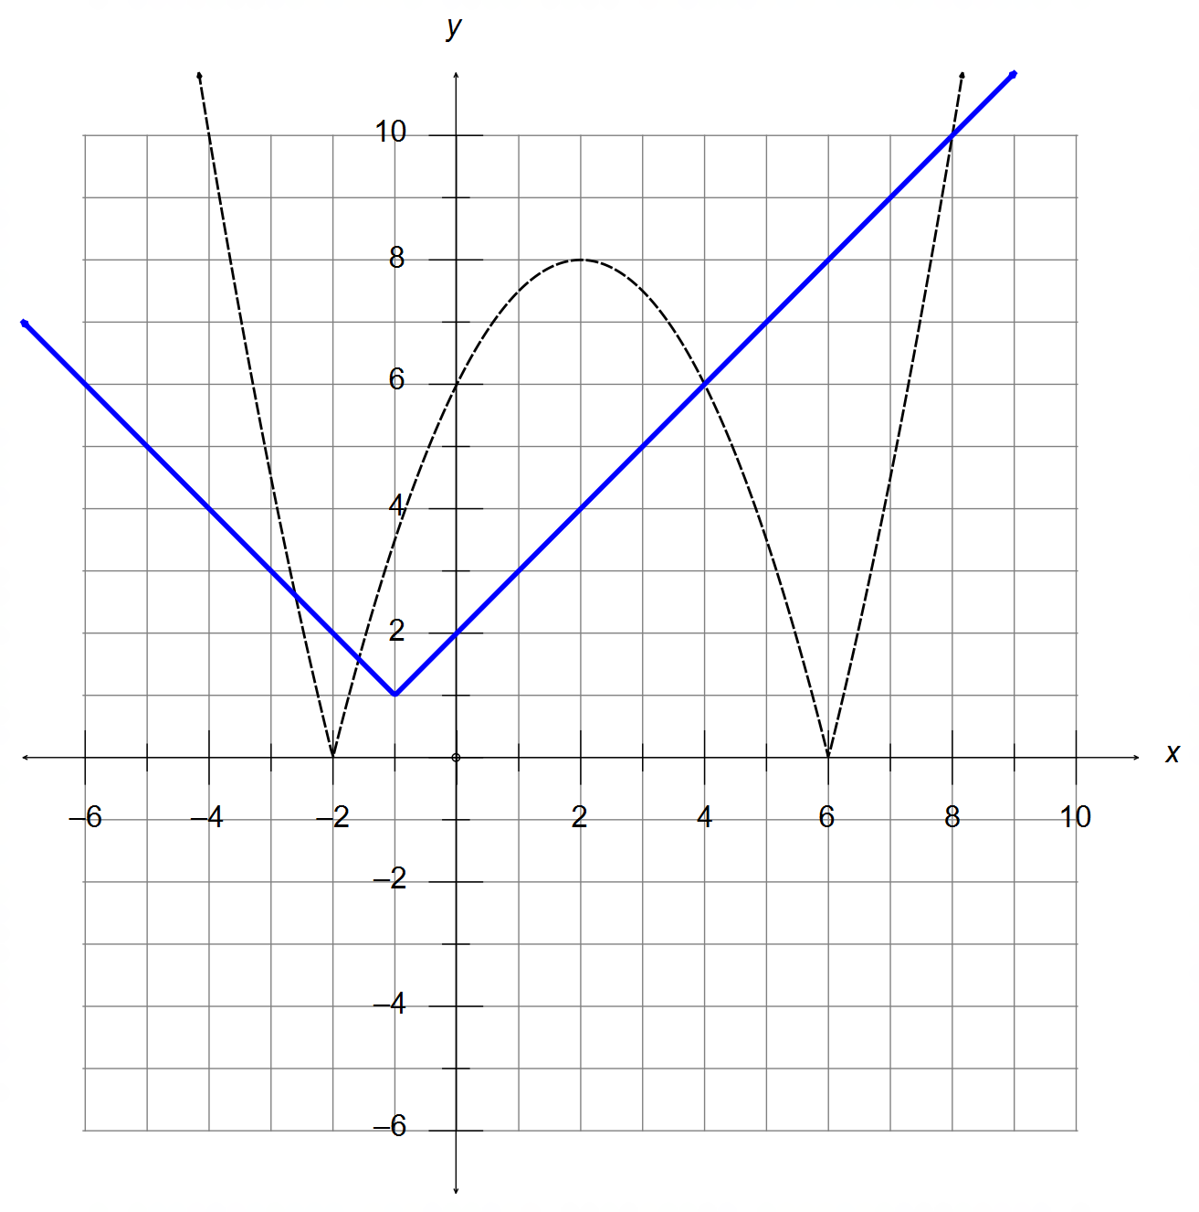13. (b) ✓✓

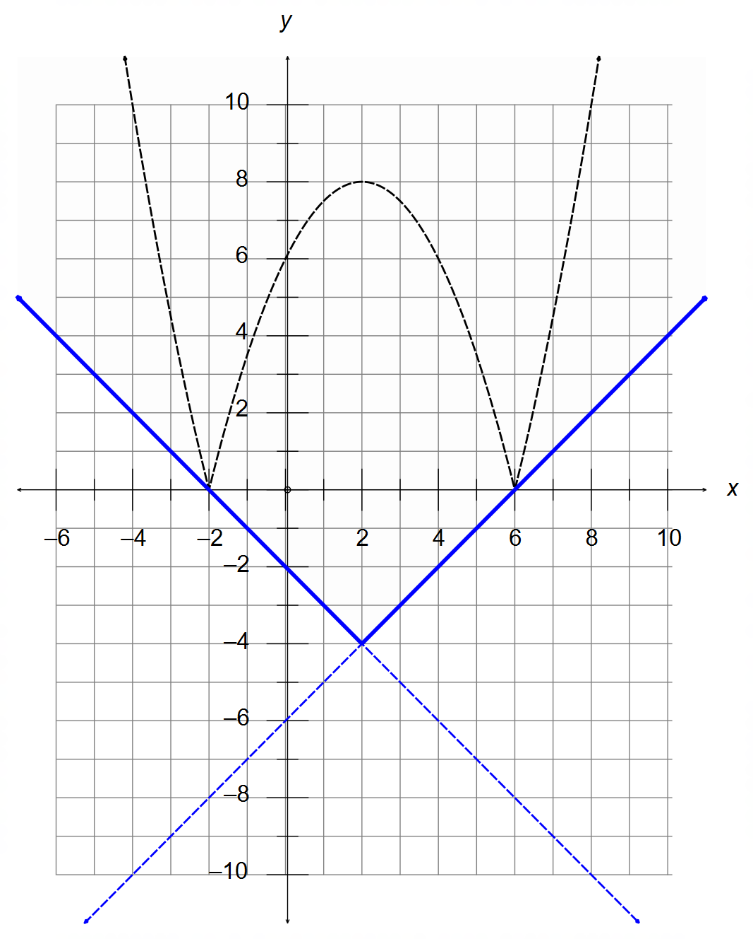 (c)

From the diagram above:

(i) ✓✓

OR ✓

(both solutions must be given)

(ii) ✓

AND ✓ [10]

14. (a) ✓

centre at and radius ✓✓

(b)

centre at and radius ✓✓

(c) ✓

✓

and ✓

(d)

✓

✓ [10]

15. (a) See diagram below.

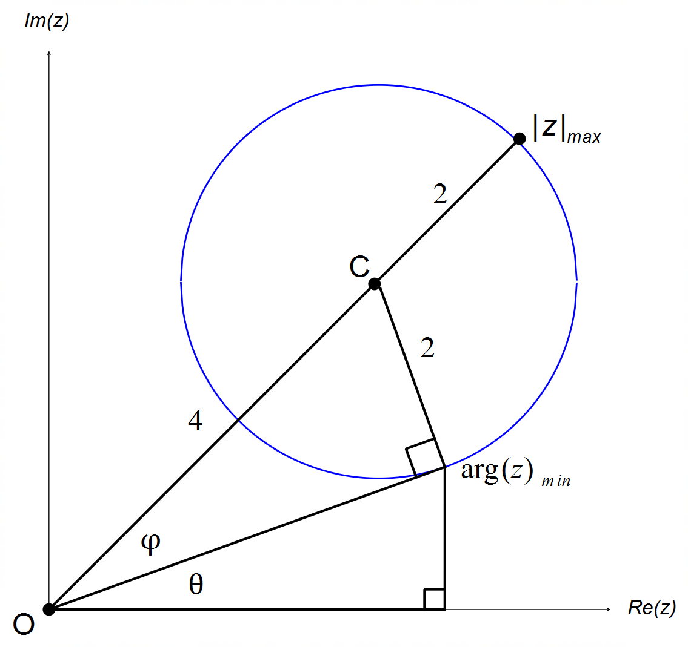

(i) units ✓✓

(ii) ✓

✓

✓

(b) (i) ✓

✓

(ii) ✓

✓

✓✓

as required [11]

16. (a) ✓✓

is its own inverse ✓

(b)

Domain ✓

Range ✓

(c) Since and are perpendicular, a reflection

of does not affect the symmetry of over ✓

therefore, the reflected function continues to be its own inverse ✓

(d) ✓

✓

✓ [10]

17. ✓

✓

is also a root of ✓

✓

✓

is also a root of ✓ [6]

18. ✓

✓

✓

Domain ✓

Range ✓ [5]